[An Android Based Mobile Application for Tracking Daily Expenses](https://www.researchgate.net/publication/357644872_An_Android_Based_Mobile_Application_for_Tracking_Daily_Expenses?enrichId=rgreq-af737861f12426a99d038920b7c10b90-XXX&enrichSource=Y292ZXJQYWdlOzM1NzY0NDg3MjtBUzoxMTA5NDE5Mzg3NTU5OTM2QDE2NDE1MTc2MDIxNDE%3D&el=1_x_3&_esc=publicationCoverPdf)

By

## ABSTRACT

This study is aimed at developing an android based mobile application capable of monitoring and controlling personal expenses, as well as cautioning the user against reckless and unbudgeted spending. The developed system was designed using system flowchart, use case diagram, sequence diagram, class diagram and system architecture diagram. It was implemented using Java programming language on android studio and My SQL. The developed system was evaluated based on basic functionality tests performed on the individual modules, the integrated testing as well as the overall function testing. The results of testing the functionalities of the developed system showed that all the modules worked properly when tested individually. They rejected invalid inputs and responded promptly to user requests. Database operations such as insert, update, delete and add that were performed yielded expected results, and data consistency / integrity are maintained in the reports generated. Thus, the developed system provides an easy to use, portable and secured means of enhancing financial sustainability and promotes individual and societal economic growth via fiscal discipline.

Keywords: Android, mobile application, expenses, module, system.

## 1. INTRODUCTION

As technological innovation develops, numerous Information Technology (IT) based applications are developed to aid individuals and organizations in performing tasks, especially those being carried out on daily basis. This android based mobile application for tracking daily expenses aims to automate the record keeping and monitoring of daily expenses. In those days, a costs day book was used to monitor day to day costs, periodic costs and ascertain the financial plan manually. Nowadays, the greater part of the world is utilizing advanced mobile phones and a standout amongst the most utilized is most recent version android mobiles. The wide use of these android mobile phones and their ability to run software applications, make a lot of sense in making this application android based. The use of this application will among other things help to monitor rate of spending, refresh information and give warning notification among other things.

According to Brownlow (2012), a smart phone is built on a mobile operating system with advanced technology and computing capabilities. It all started with Symbian in 2000, which was the first modern mobile OS on a smart phone followed by Blackberry in 2002, Apple iphone in 2007, Android in 2008 and so on. The launch and increase in sales of smart phones over the last decade clearly indicates that many people are making use of these phones especially for tasks that require computing capabilities. Managing expenses is important for our rapidly-growing daily life. Gone are the days when one had to sit down with a notepad and a sky-high stack of bills and receipts to figure out one’s income, expenses, and overall budgetary plan. These days there are all kinds of spreadsheets and programs that are meant to make one’s financial planning a lot easier and more efficient. But, with the shortcoming of carrying laptops around, all these make comprehensive budgeting and tracking measures largely confined.

Peijiang (2012) and Andtek (2012) proposed systems of solving the task of managing personal expenses and income. However, there are problems of how to maintain budget efficiently and with ease, and how to avoid overdraft fees, unexpected shortages, and that sinking dread of being broke. Therefore, there is the need to develop an easy to use and portable system capable of monitoring and controlling personal expenses, as well as cautioning the user against reckless and unbudgeted spending, hence this study.

## 2. LITERATURE REVIEW

Expense is an outflow of money to another person or group to pay for an item or service, or for a category of costs. It is a cost that is "paid“, usually in exchange for something of value (Carvalho and Basso, 2014). Examples of our daily expenses include buying of recharge cards, buying food, junks, provision, fruits, subscription, clothing and so on. According to Kim (2012), expense management refers to the system deployed by a person or business to process, pay, and audit personal or employee-initiated expenses. Expense management includes the policies and procedures that govern such spending, as well as the technologies and services utilized to process and analyse the data associated with it.

In Expense management automation, there are four main factors that drive a person or business organization to automate their expense management processes (Turpin, 2017):

1. Compliance focus: 57% have poor visibility into spend and compliance so they do not know how much they are spending and they cannot ensure that all of those costs remain within the boundaries of the company's handbook or policies regarding expense reporting
2. Cost reduction: 38% need to reduce expense processing costs
3. More control: 35% have no control over total spending
4. Improved productivity: 20% need to eliminate manual and paper processes to improve productivity and satisfaction.

Below are identified strategies tailored towards expense management systems

1. Spreadsheets: Spreadsheets can be an easy, cheap way to keep track of expenses, but they still have paper receipts that go along with them that can be lost or damaged. This can also be a labour-intensive method and it can be confusing if employees are not good at using spreadsheets (Wild, 2010)
2. Paper forms: Paper forms work well with paper receipts. This is also an inexpensive way to manage expense reports. However, this can amount to a lot of manual work of logging and tracking these reports for both employees, approvers, and the people who need to pay the bills in the accounting department (Peijiang, 2012).
3. Software: Software reduces the workload, but it may also be expensive to implement. According to the Aberdeen Group's report, "Best-In-Class T&E Expense Management: How They Do It”. The Software can solve the major problems of compliance, manual labour, approval time, and the cost of expense reporting overall.

## 2. RELATED WORKS

Expense Tracker was developed by Andtek (2012), this system provides the users with the facility to save their daily expenses. The main problem with this system, which arose from users complaints, is that it does not provide the customization option for currencies. Hence, it may not be very appealing to people from different countries to use since people tend to be more comfortable with currency based transactions. The main learning outcome from this system which came in mind is to customize the options for currencies so that users from other countries will not suffer the same problem which they are suffering in the current system.

Peijiang (2010) developed the Expense Manager which has a lot of features for expense monitoring. This system provides budget alert in form of notifications to caution users whenever their spending limits are exceeded. However, the system is limited to having facility for keeping expense reports of the users that have not passed a year.

Kim (2013) developed Coin Keeper which provided the same functionalities as the Expense Manager, but could not provide monthly, yearly and graphical reports which the users of the system had complained about. Also, Peijiang (2012) developed the Daily Expense Tracker which provides solution to the majority of the problems left unsolved by the previously reviewed systems. The system is good, but heavy because of functionalities like calendar which allows the users to view the report on daily basis. It is observed that this application provides graphical layout wherever possible, for instance, using symbol for cash instead of written format. The proposed system uses more of texts where necessary to depict things instead of images, hence making the app lighter and loads faster, without compromising efficient interface design.

Kim (2015) developed a Daily Expense Manager which comprised of mobile and web platforms for expense management and has many amazing features that help users to track their daily, weekly and monthly spending without having to spend much time on the application. This was achieved by the use of expense categories that allows the user to manage expenses under categories such as food, clothing, energy and the likes. Other features include currency customizable expense and income categories.

The main limitation of this system is that it did not provide synchronization with web server, and as such, the user has to either choose to use the web or mobile platform. The proposed system employs some of the excellent features derived from past works such as the “expense category” and “currency choice” features implemented in Daily Expense Manager. This will help the user to spend lesser time on the app since there would be no need of typing details of a particular expense.

## 3. THE PROPOSED SYSTEM

Top down coding approach was employed in the application software implementation using Java programming language on android studio. This involved dividing the implementation process into subunits or modules and each subunit being further divided into even smaller subunits. This process of division is repeated until each unit is sufficiently small enough to be conveniently coded (implemented) from scratch as an independent entity that performs a clearly defined operation. The analysis and comparison of existing mobile applications was done and this resulted from the review of related implemented methodologies. The critical analysis led to the adoption of the scheme of requirement specifications that highlighted the nature of the expense tracker mobile app implemented in this work. The process followed in designing the mobile application is succinctly written in the following sections.

### 3.1 Flow Chart Diagram

Figure 3.1 represents the flow charts of the proposed system. The figure shows the sequence of flow of actions from start to stop. The user starts the app, creates password, log in and allowed to add amounts spent under specific categories. The user then proceeds to view transaction, expenses report and add budget limit. When budget limit is exceeded, the app pops a message to caution the user and the user exits the app.

Figure 1: System Flowchart



Add

Budget



Start



Create

Password



Log In



Add

amountsp

ent



Add

categories



View

transactions



View

expensesr

eport



Exceed

Budget



Yes



No



Pop up

message



Exit



Stop

### 3.2 Use Case Diagram

The use case diagram for the proposed system is represented in Figure 2. It shows the roles the user performs on the system. In the User Input section; the user can log in, add categories, add amount spent, change the amount, view the transaction and add budget. In user view section; all transactions can be viewed, as well as total expense, weekly, monthly and yearly reports.

### 3.3 Sequence Diagram

The sequence diagram for the proposed system is represented in Figure 3. It shows objects interactions arranged in time sequence. The user launches the application on an android phone, Logs in with a valid password, the system confirms the password and if not valid displays wrong password, otherwise, a successful log in leads the user to the landing page of the mobile application where the user can proceed to add expenses, category and select currency of choice from settings. Thereafter, the user can request for the desired report.



Actor



Login



Login



Add Categories



Add Amount Spent



Change the amount



View the transaction



All Transactions



Total Expense



Reports



Monthly Report



Weekly Report



Yearly Report



Date Range Report

Add Budget

Figure 2: System Use case diagram.

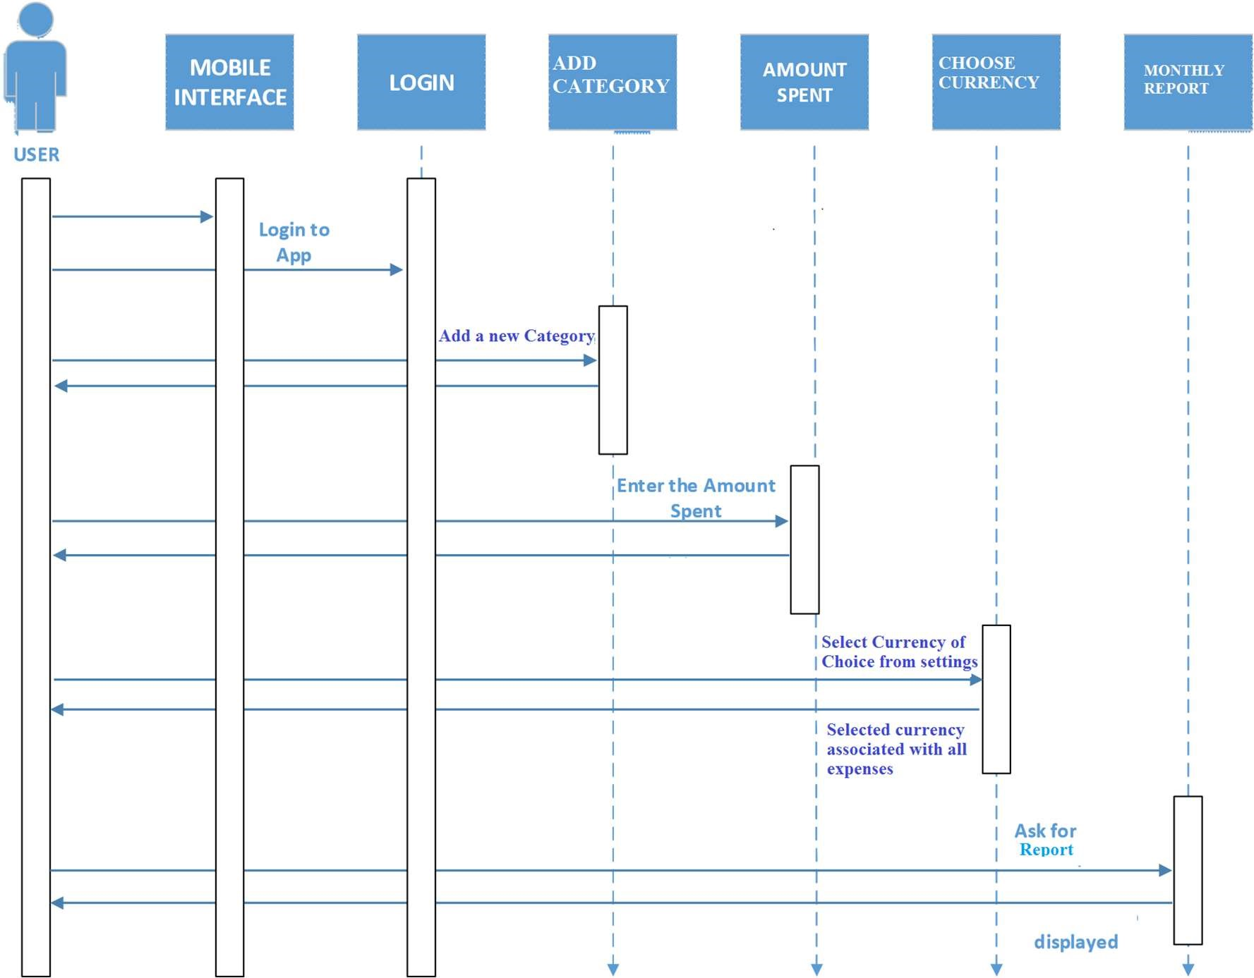

Figure 3: System Sequence Diagram

### 3.4 Class Diagram

The class diagram for the system is represented in Figure 4. It shows the relationship between classes and their components. The user interacts with the system and the system access the application and calls functions from the server.

### 3.5 System Architecture

The technological approach for implementing the mobile expense tracker is based on an architecture which provides the necessary framework for the services, components and interfaces using the client/server architecture. At the back-end, the vital services include the recording and analysis of expenses and display of monthly reports among other peripheral services. The database, the mobile android OS based phone, and the developed application form the technological infrastructure for recording, analyzing, managing users’ and displaying monthly report of expense information.

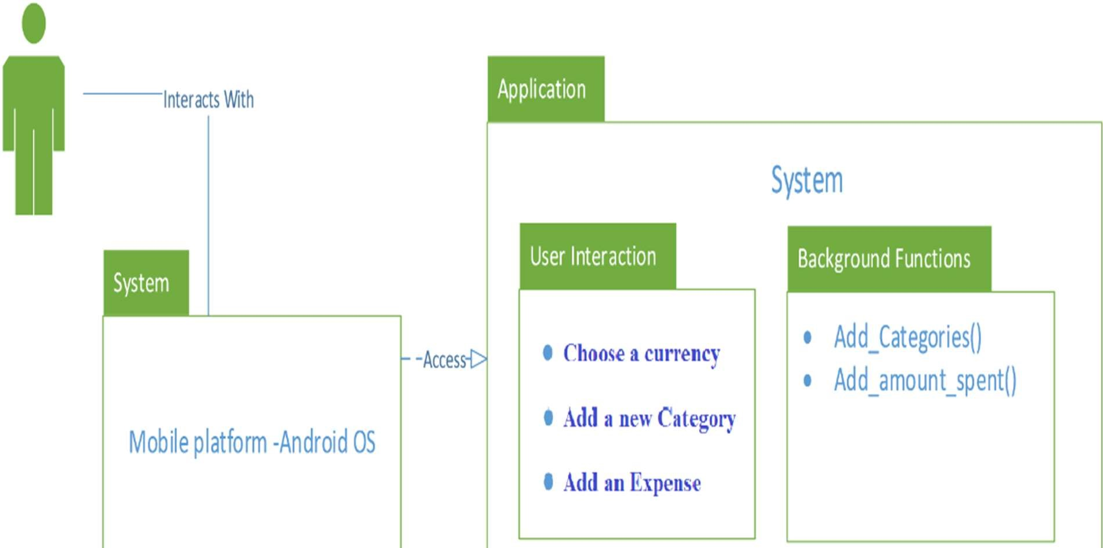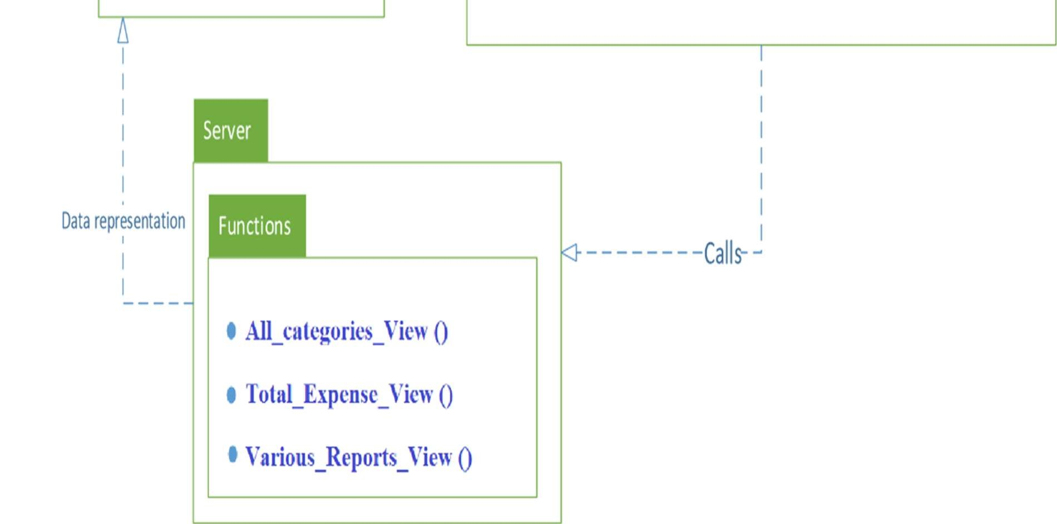

## Figure 4: Class diagram showing relationship between classes and their components

A client-server mobile application software on android OS helps in the financial management. The proposed system helps in planning and monitoring one’s budget to identify wasteful expenditures, adapts quickly as financial situation changes, and achieves financial goals. One can use this planning process to prioritize spending and focus on the things that are most important. The database (DB) stores every active data such as users’ details, expense details and reports etc. The application server manages the manner in which the mobile application communicates with the database as inputted and retrieved by the users.

Apache Tomcat is open source software used for the implementation of the Java Servlet and Java Server Pages that controls the SQL database communication with the app server. The client represent the side of the application software that the users interact with, majorly the interface that the user makes use of in order to input and retrieve data. The client and server as well as the database are to be resident on the mobile phone using servlet/JSP technology for database interaction as shown in the system architecture diagram in Figure 5.

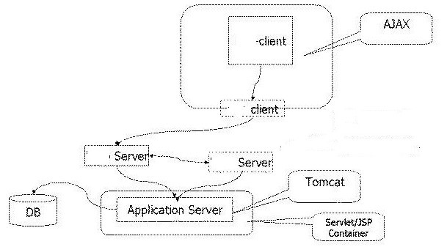

## Figure 5: System Architecture

### 3.6 Description of Modules

Pseudocodes for Creating a Password

1. Start
2. Enter Password
3. Confirm Password
4. Press Enter
5. Password saved
6. End

Pseudocodes for Selecting Currency

1. Start
2. Pick Currency Options from settings tab
3. Select preferred Currency
4. Press Enter
5. Chosen Currency saved
6. End

Pseudocodes for Logging in

1. Start
2. Enter created Password
3. Confirms if Password is correct
4. If wrong, displays wrong password
5. Else, Log in successfully
6. End

Pseudocodes for Adding a Budget

1. Start
2. Pick Add Budget from the Expense Menu
3. Create New Budget
4. Press Enter
5. Current Budget saved
6. End

Pseudocodes for Generating Report

1. Start
2. Click on Expenses Report
3. Select choice of report
4. Report displayed based on choice of report
5. End

The basic functionality of the app was tested first one at a time, and after integrating it with other modules continuously and performing functionality tests. These include:

* Functionality of each module based on requirements specifications
* Check for valid and invalid data
* Tests carried on local host intranet
* Checks to ensure interdependence of module.

Also, data stored in the database was checked for consistency and validity as follows: • Data checks was performed on all types of database in scope

* Data checks like insert, update, retrieval was done for all possible transactions
* Check whether database logging of data was proper or not
* Data validity check

### 3.7 Users’ Guide

This expense management system has been developed to a level that will enable users to navigate around the features easily and quickly. The system is menu driven, thereby, for any particular operation carried out, a menu must be specified and there are few number of options for the user to select depending on what the user wants to do. Therefore, the application has been made simple enough for use, and no extra document is needed as users’ guide aside the details offered in this section of the work.

## 4. SYSTEM FUNCTIONALITY& DISCUSSION

The user is expected to register on the platform when using the app for the first time and set up a password that must be remembered and correctly supplied for subsequent login to the app. A successful login leads the user to the landing page of the mobile application, which shows the tab for the user to add new expense for the day. For a user to be able to add an expense, an expense category must be selected. Some daily expense categories have been pre-programed into the software. The user is expected to add new categories that suits personal expense lifestyle, and can add as many expenses under as many as possible expense categories per day.

The menus of the expense management mobile app are “Today” which means ongoing expenses for the day”, “Expense reports” which can be daily report, weekly report, monthly report, report by date and report by date range. Others are “expense categories” as discussed earlier and “App settings”. Calendar is implemented to allow the user view expense reports for a particular day in the past or a report for a range of days. The App settings module allows the user to choose the preferred currency for the expense operations. This means people from different parts of the world can make use of the developed mobile expense management app.

Some of the app navigations are shown in Figure 6 to Figure 17. Figure 6 is the log in page where the user is expected to log in to the app with a valid password. Figure 7 shows the App menu and the landing page is displayed in Figure 8.Figure 9. shows the interface that allows user to add new expense and Figure 10 shows a day added expenses while Figure 11 shows a day’s total expenses.

Figure 12 depicts where user can be allowed to add budget which pops up a message when budget is exceeded. Figure 13 displays several expense categories and Figure 14 shows where users are allowed to add a category to the list. Figure 15 shows currency category and Figure 16 displays the weekly report of expenses while Figure 17 displays monthly report of expenses.

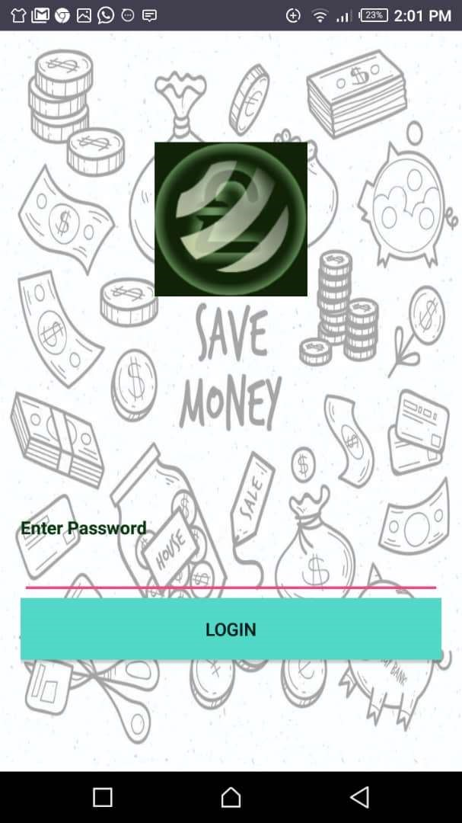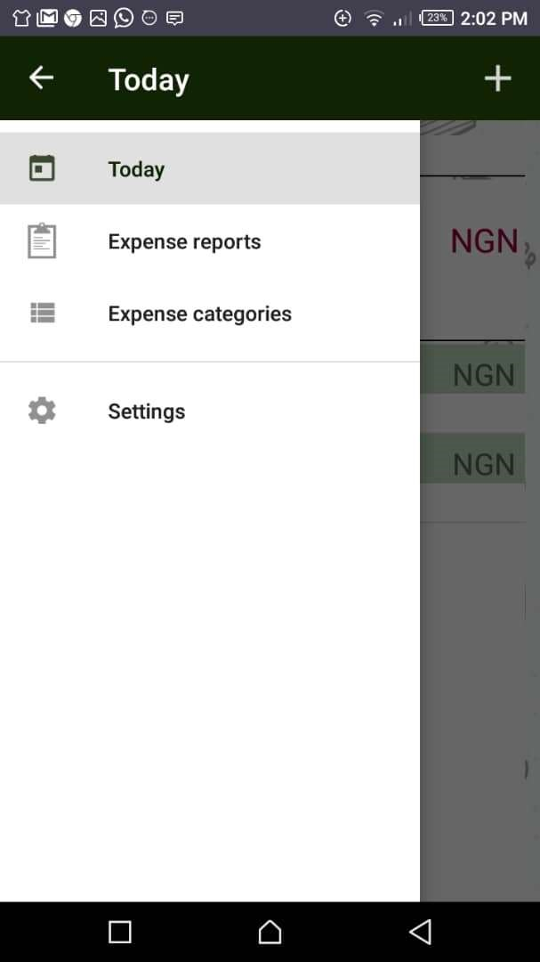

## Figure 6: The App login page Figure 7: Expense Manager’s Menu

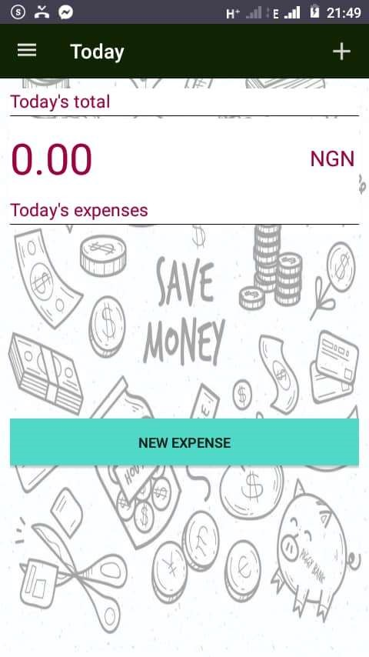 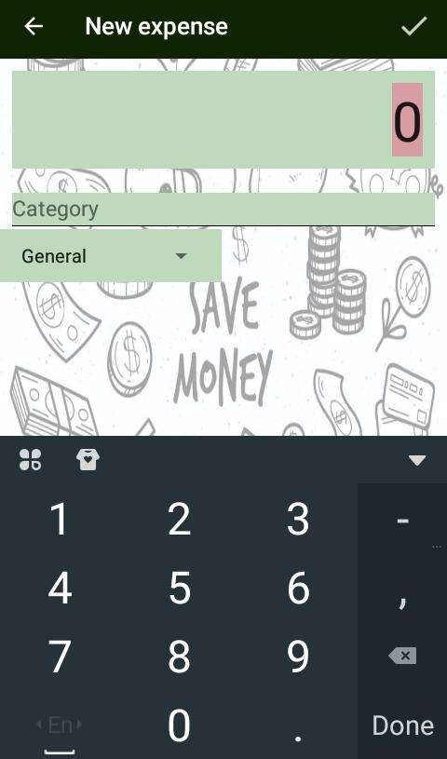

## Figure 8: The landing page (new expense page) Figure 9: Adding a new expense

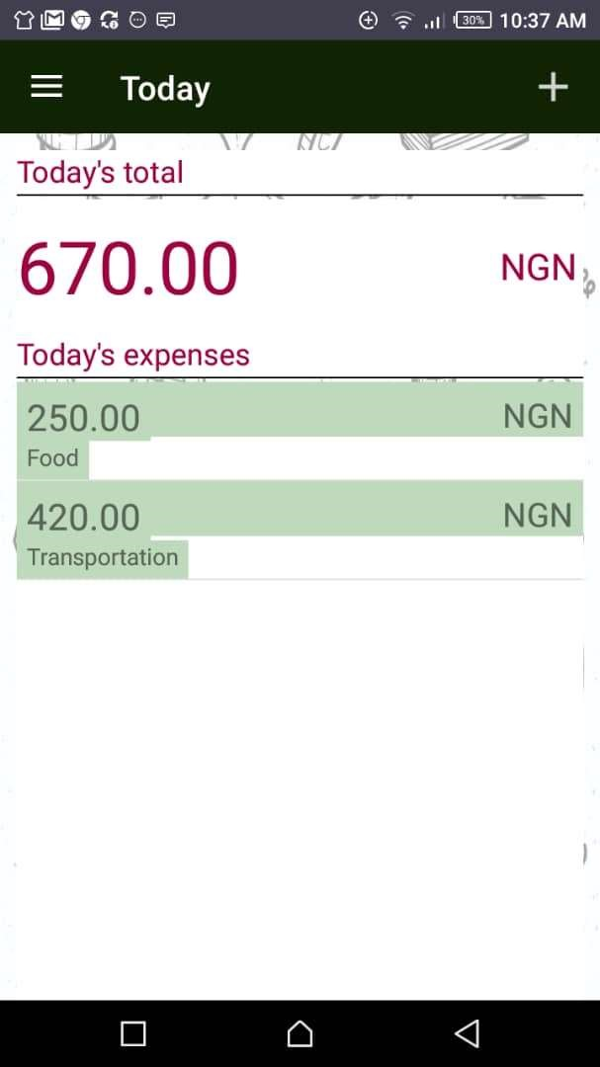 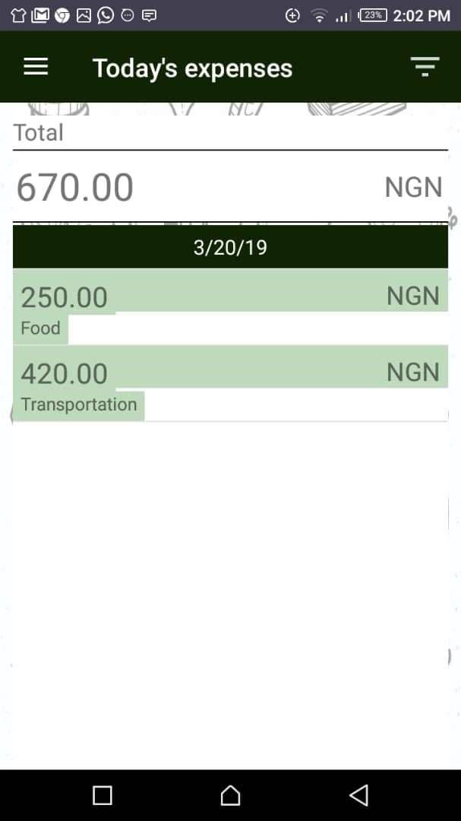

## Figure 10: Today’s added expense Figure 11: Today’s total expenses

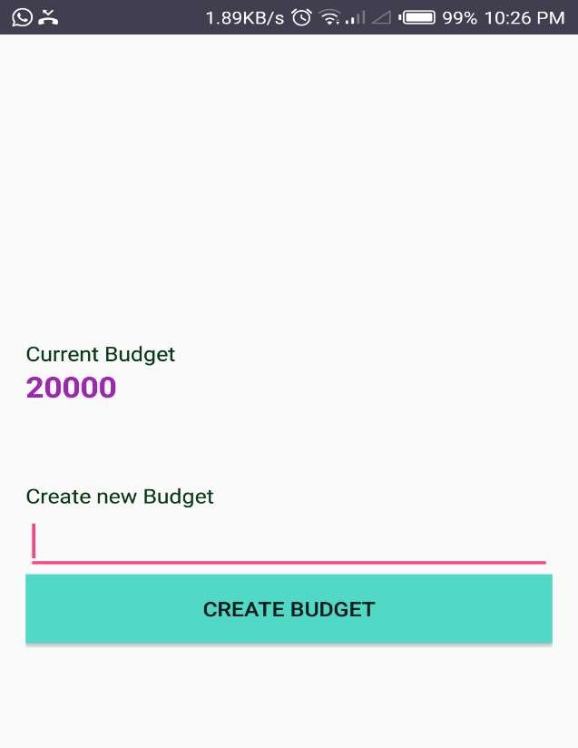 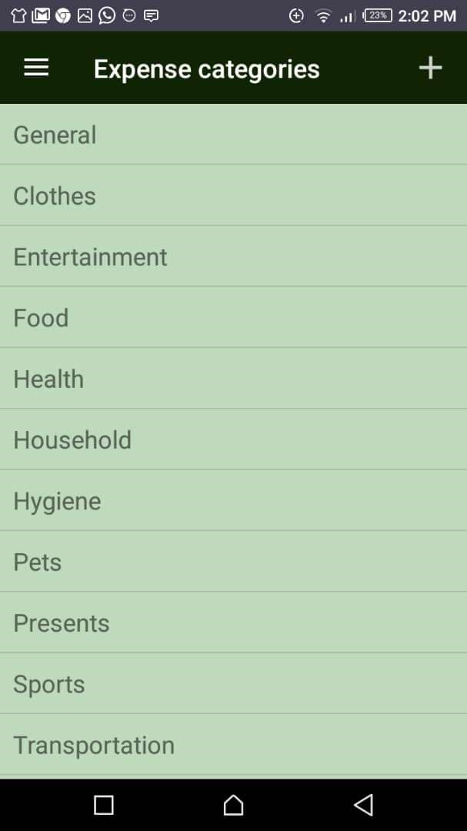

## Figure 12: Add Budget page Figure 13: Expense Category page

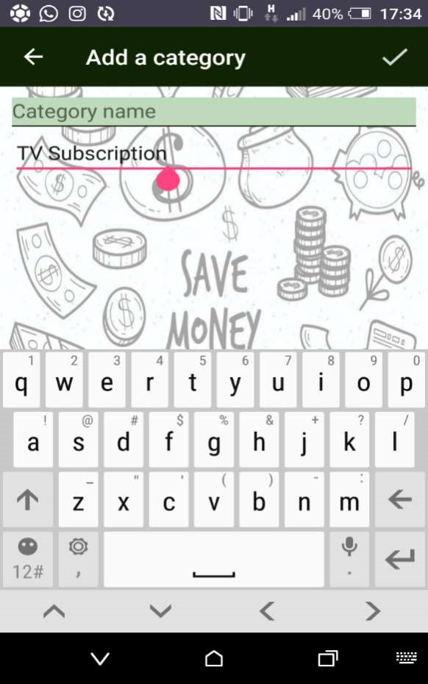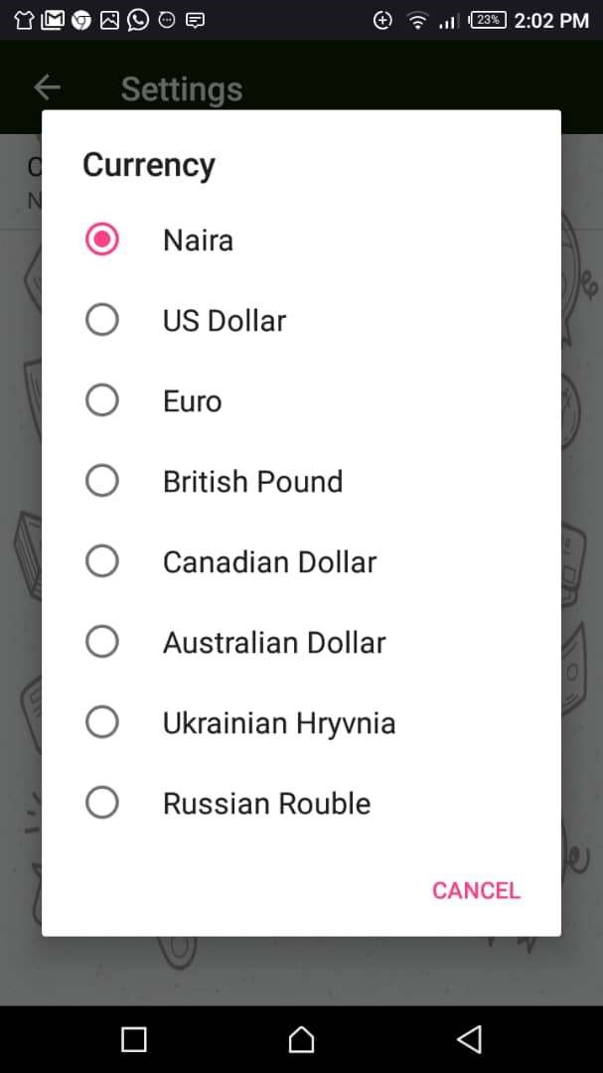

## Figure 14: Adding a new category to the list Figure 15:Currency category page

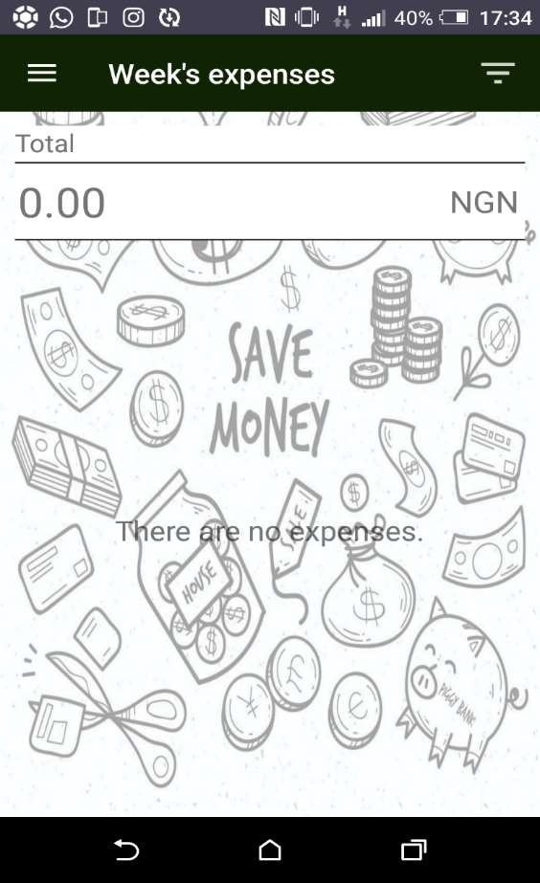 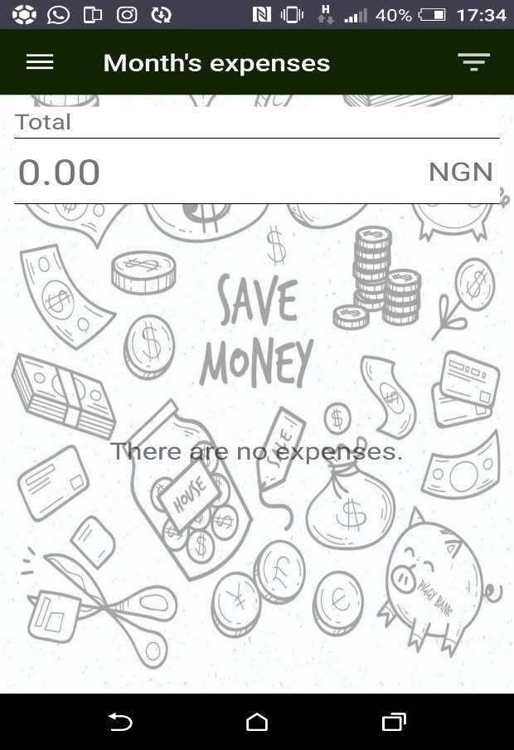

Figure 16: Weekly report of expense. Figure 17: Monthly Expenses

## 5. CONCLUSION

In this paper, the development and implementation of an Android Based Mobile Application for Tracking Daily Expenses capable of helping users to keep records of their daily expenses monitor their spending and control wasteful spending had been presented. Java programming language on android studio was used for the application design implementation. The developed system was designed using system flowchart, use case diagram, sequence diagrams, class diagram and system architecture diagram which makes the system user friendly with easy to use interface for any user including those that are not used to computer software.

The developed application would help in showing the great advantages of the use of Information technology in the financial sector of our growing economy in such a way that enhances expenses monitoring and financial life in general. It has also helped in providing more knowledge in Java programming on Android studio, Mobile app development, SQLite Server database application and integration. Hence, an android based mobile application capable of monitoring and controlling personal expenses, as well as cautioning the user against reckless and unbudgeted spending had been designed, implemented and evaluated.

View publication stats